Duplicate records are not aggregated in Fusion GL_Balance

GL_Balance :
Inserted a duplicate record for fusion string = '1109|10000|1000|0000000|000000|1931|0000' with begin_balance_dr_beq = ‘1683760.48’

And we expected this amount should be considered at Gold Table fusion_gl_balance while aggregating

select *
from delta_silver.fact_fusion_glbalances_slv where
fusion_string in (
select distinct fusion_string from delta_Silver.dim_fdmee_mapping_slv
where target_entity = 'SB1109' and source_Account ='10000' and year_period_number =202310 and source_movement NOT like 'L%' )
and year_period_number =202310
and ledger_id ='300000598726042' ;

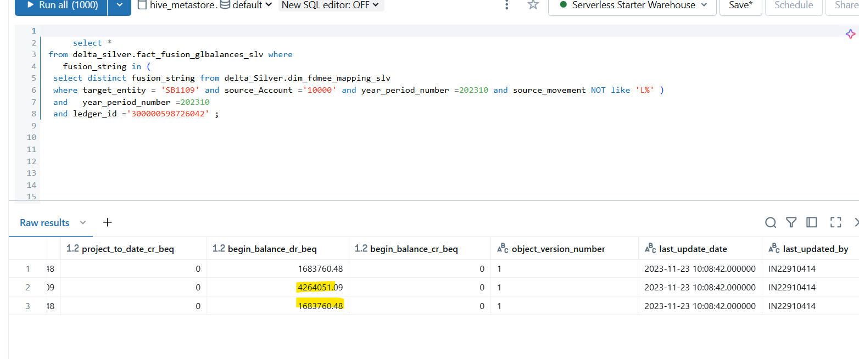
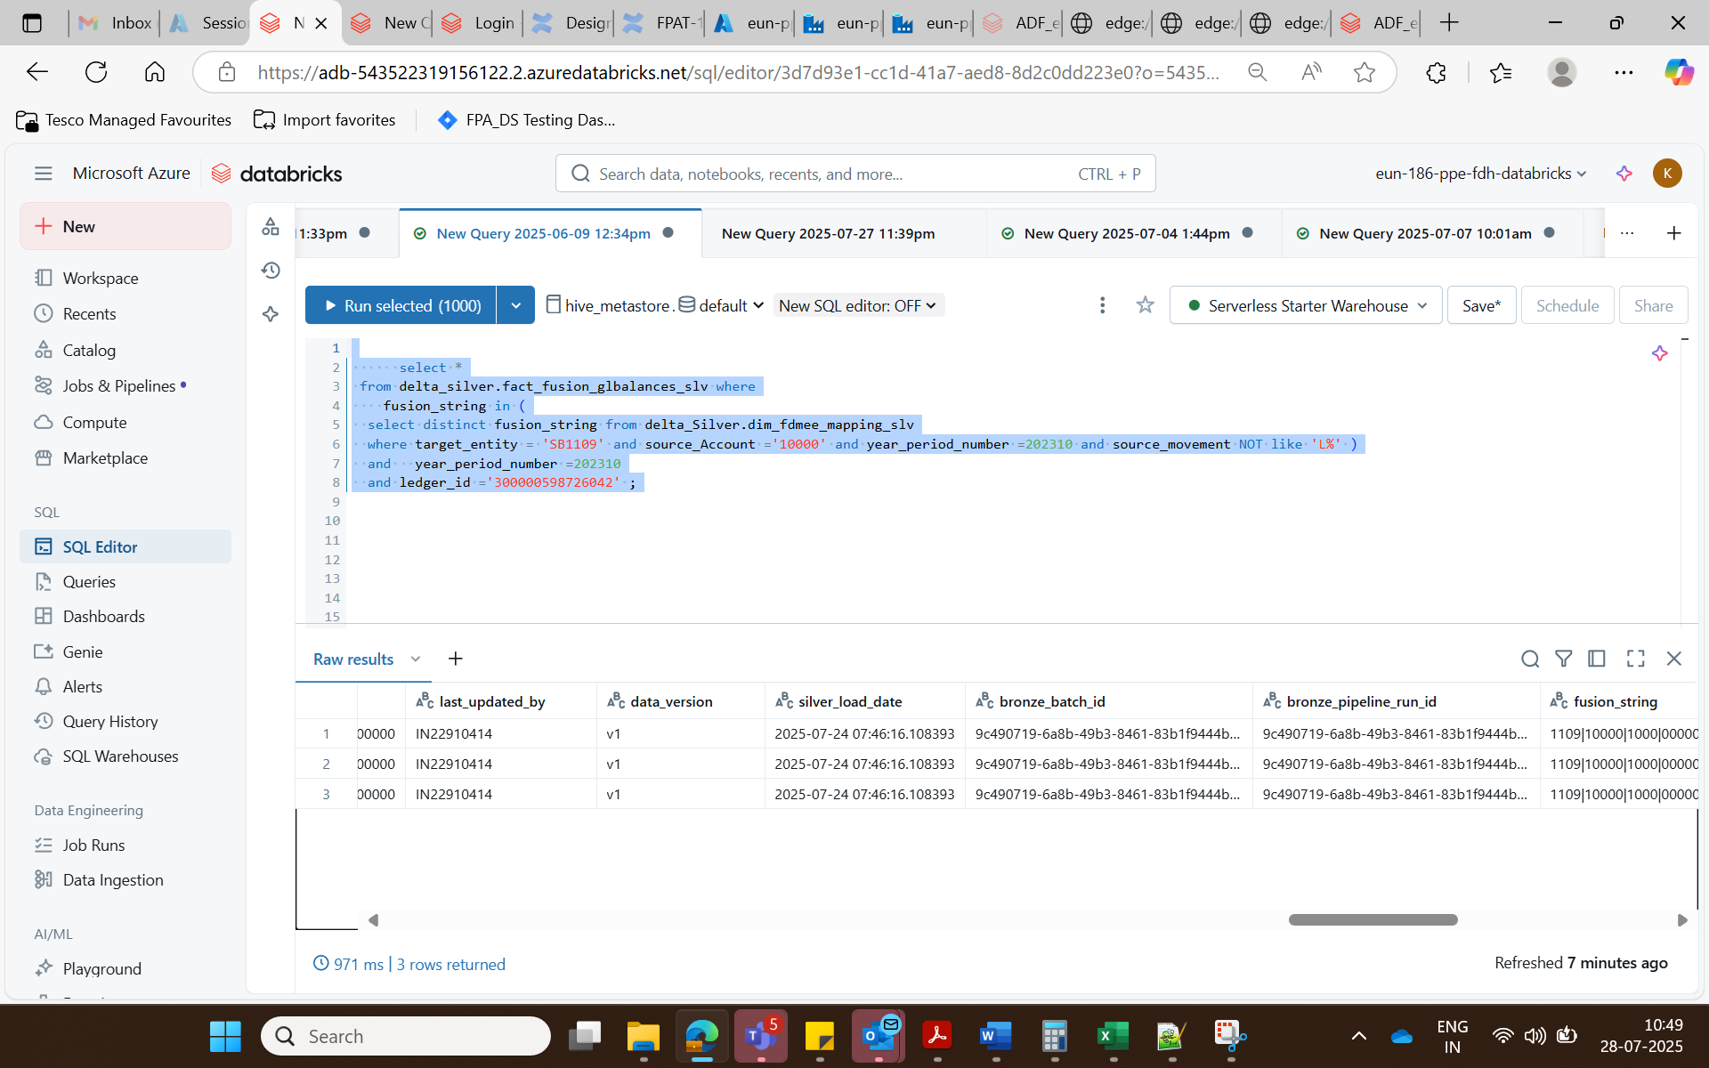

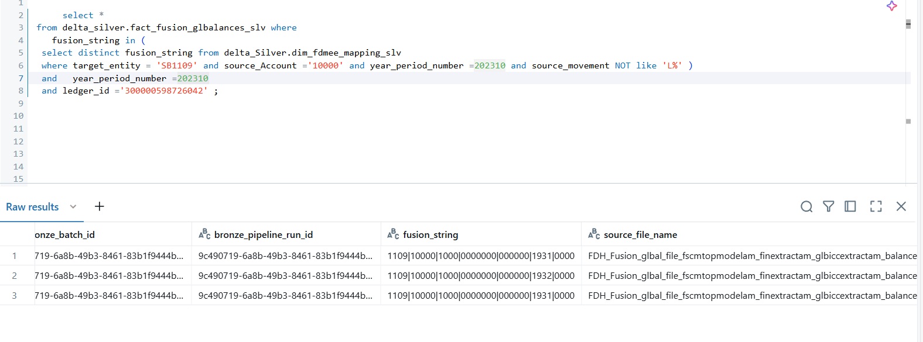
Pipeline Execution :
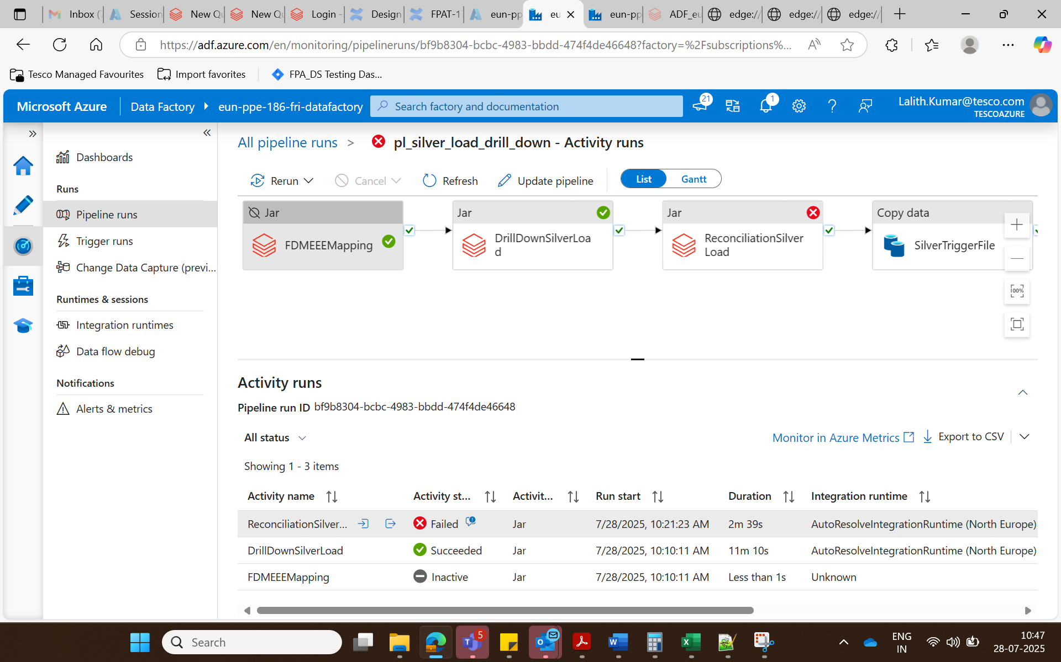

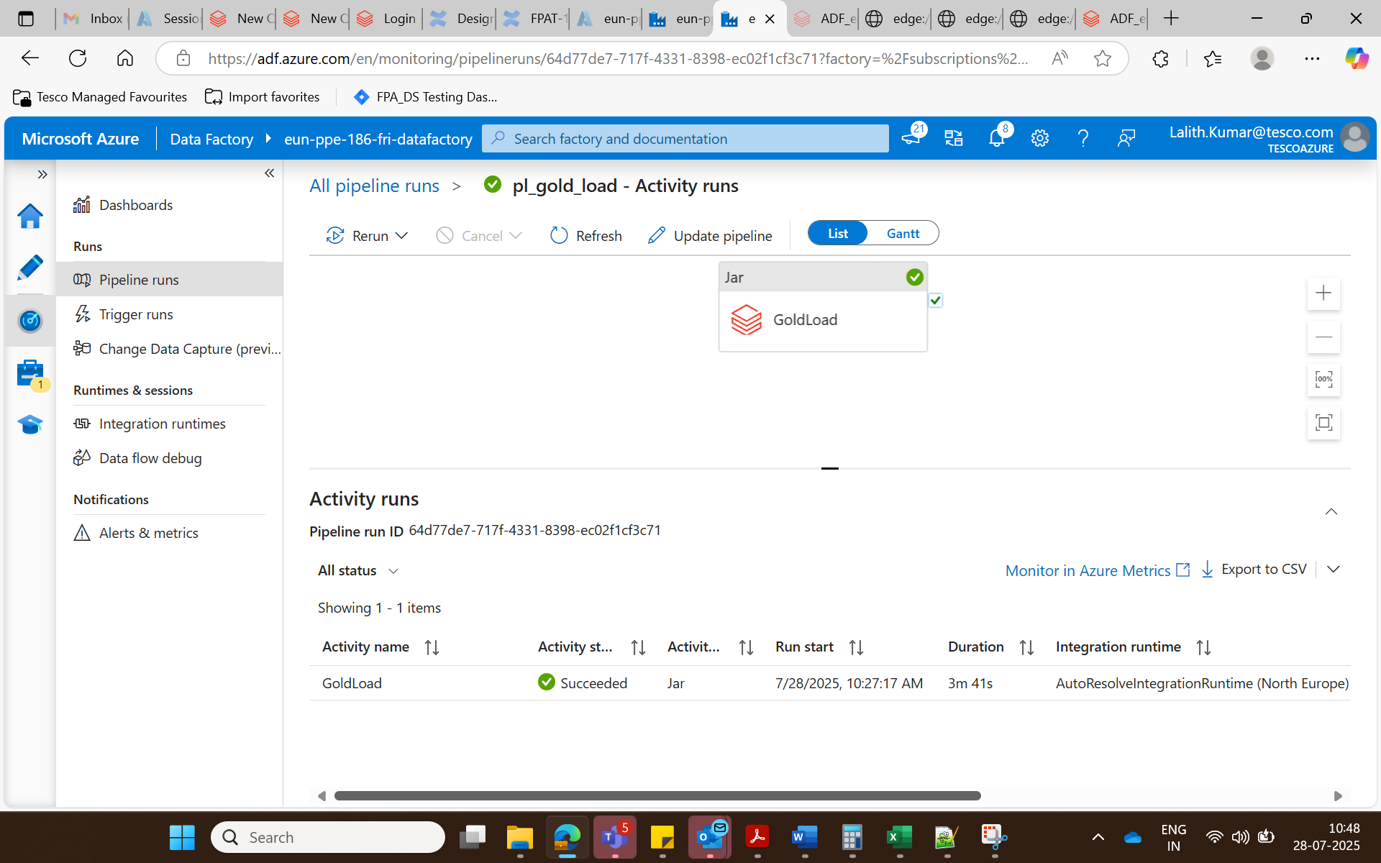
Gold_Table :
select * from delta_gold.fusion_gl_balances where gl_account = '10000' and hfm_entity ='SB1109'

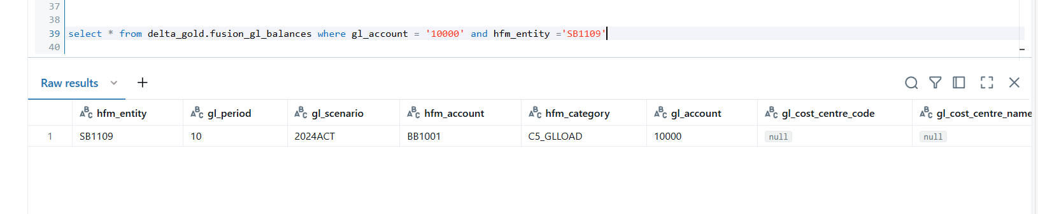

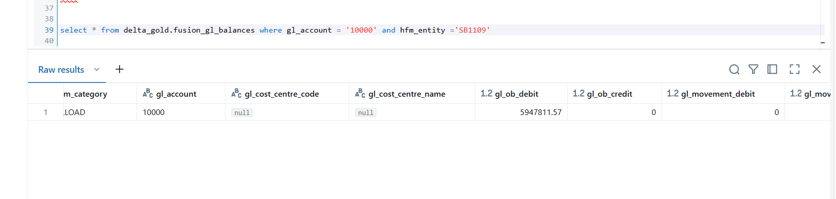
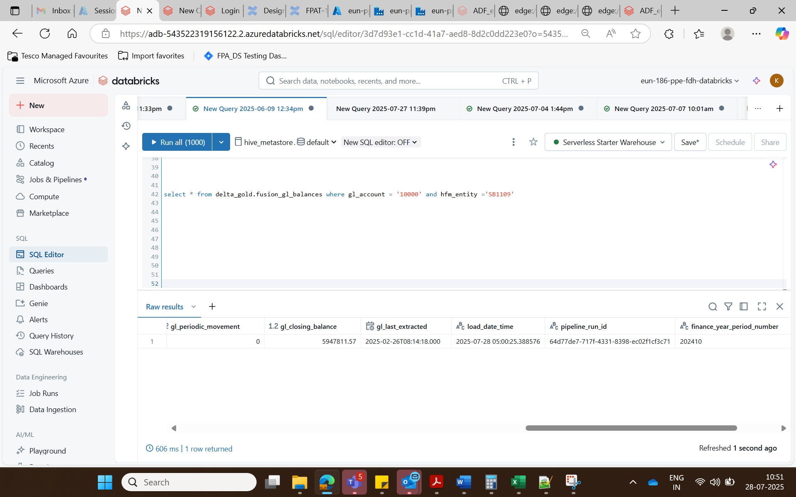
Expected Amount gl_ob_Debit : 7631572.05
Actual Amount = 5947811.57

